**Project Pulse – Solutions**

**Question 1: Paste the screenshot of the resulting screen.What are the Top 10 Subcategories?**

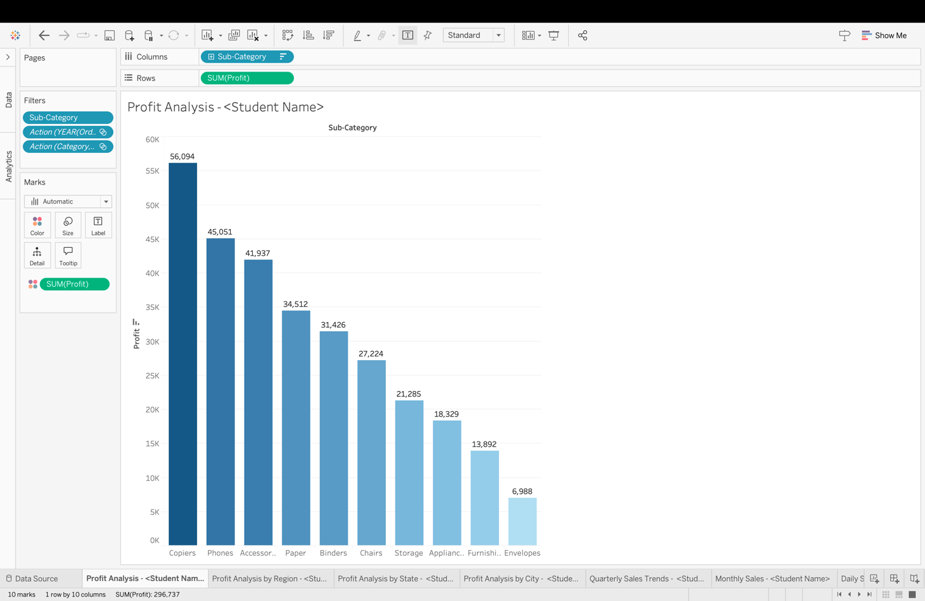

The Top 10 Categories are:

Copiers, Phones, Accessories, Paper, Binders, Chairs, Storage, Appliances, Furnishings and Envelopes.

**Question 2: Paste the screenshot of the resulting screen.**

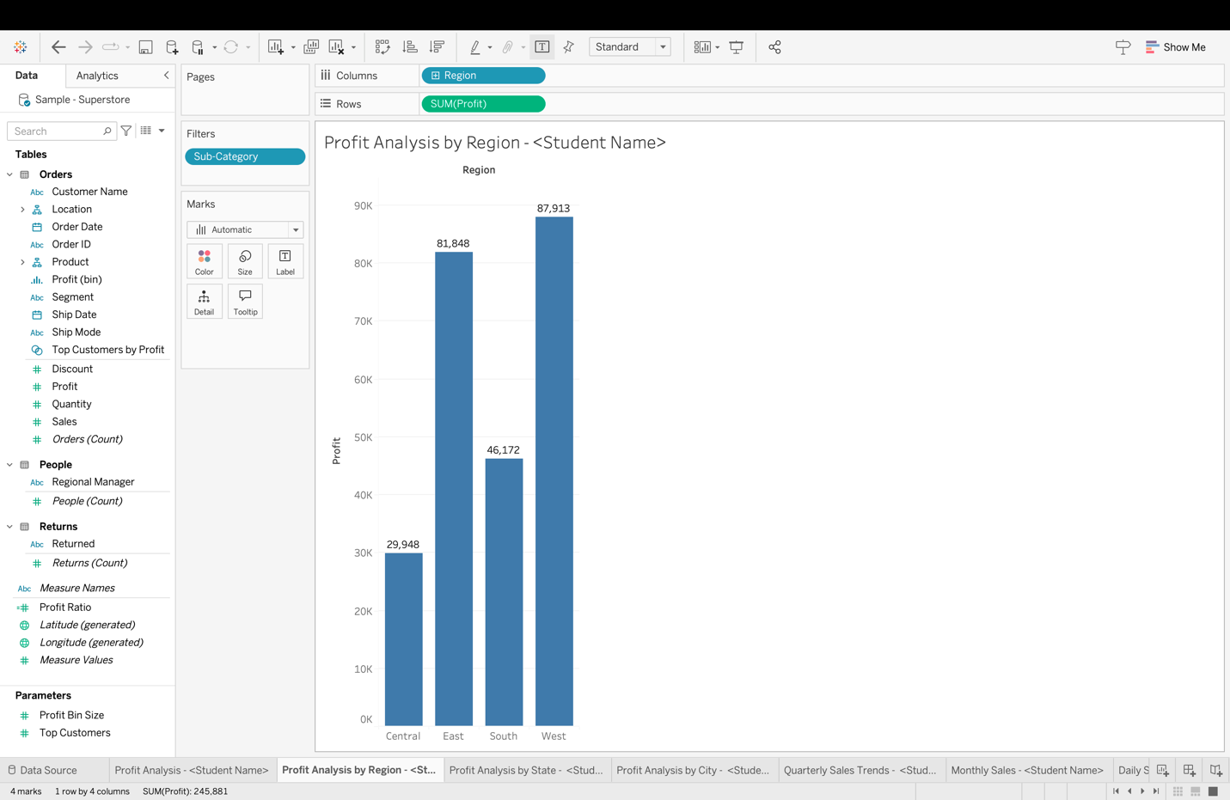

**Question 3: Paste the screenshot of the resulting screen.**

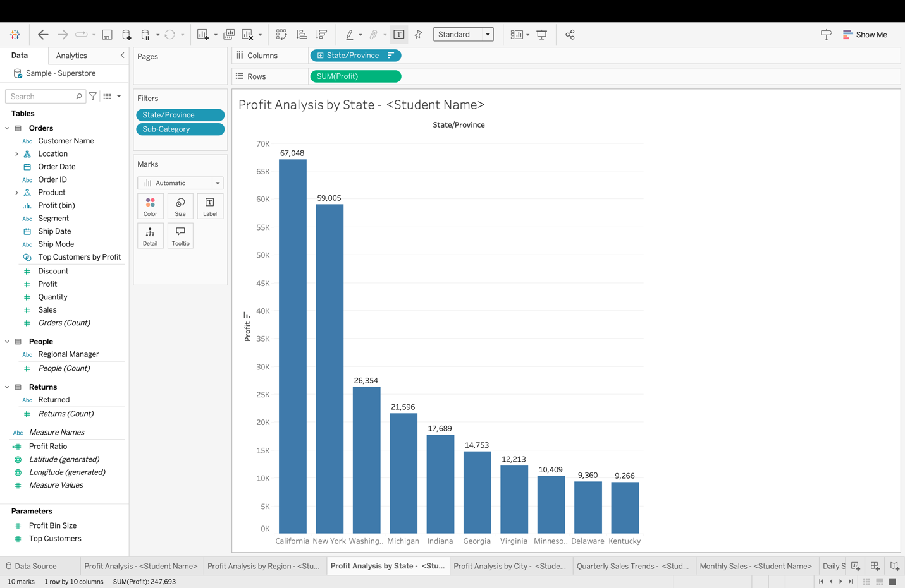

**Question 4: Paste the screenshot of the resulting screen.Which City has the Highest Profit? What is it?**

* New York City recorded the highest profit, amounting to **$49,335**.

**Question 5: Paste a screenshot of your screen showing the quarterly and yearly sales. Which quarter and year had the highest sales?**

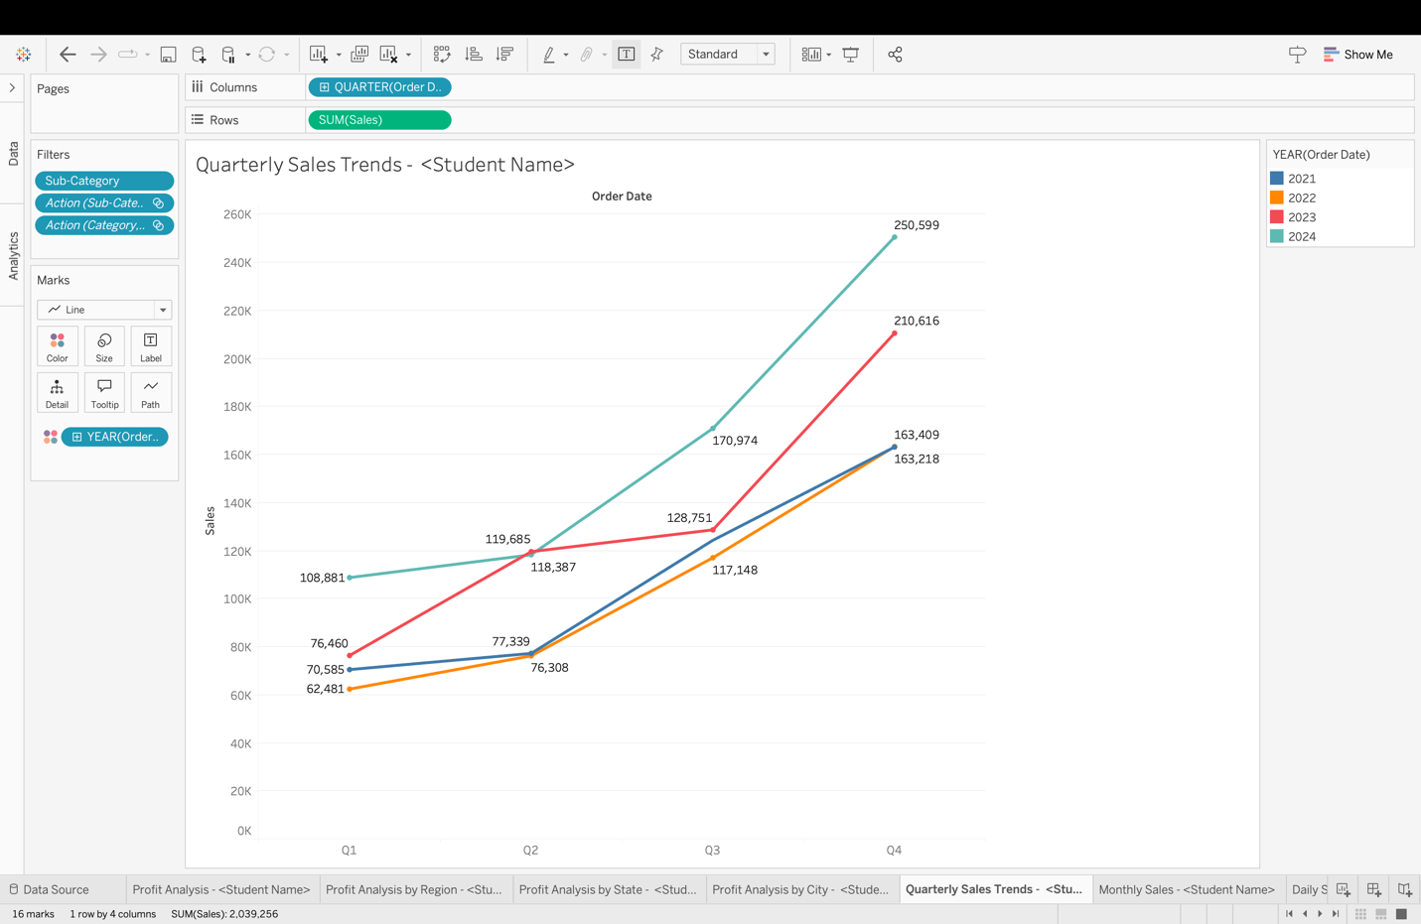

* Quarter 4 of 2024 achieved the highest sales, totaling **$250,599**.

**Question 6: Paste the screenshot of the resulting screen. Which month has the highest sales?**

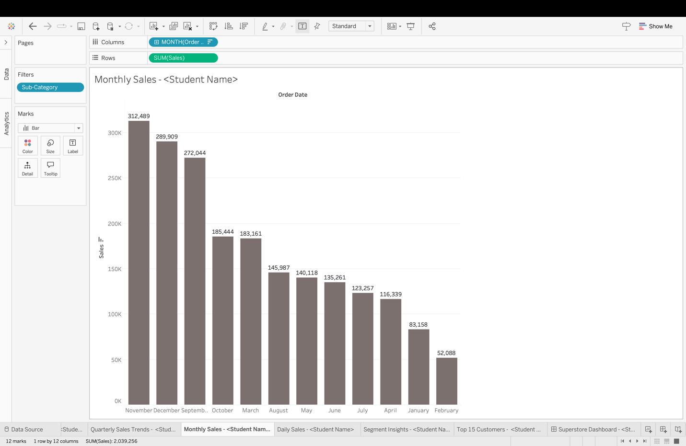

* The month of November recorded the highest sales, totaling **$312,489**.

**Question 7: Paste the screenshot of the resulting screen. What are the days when Sales is above 70,000?**

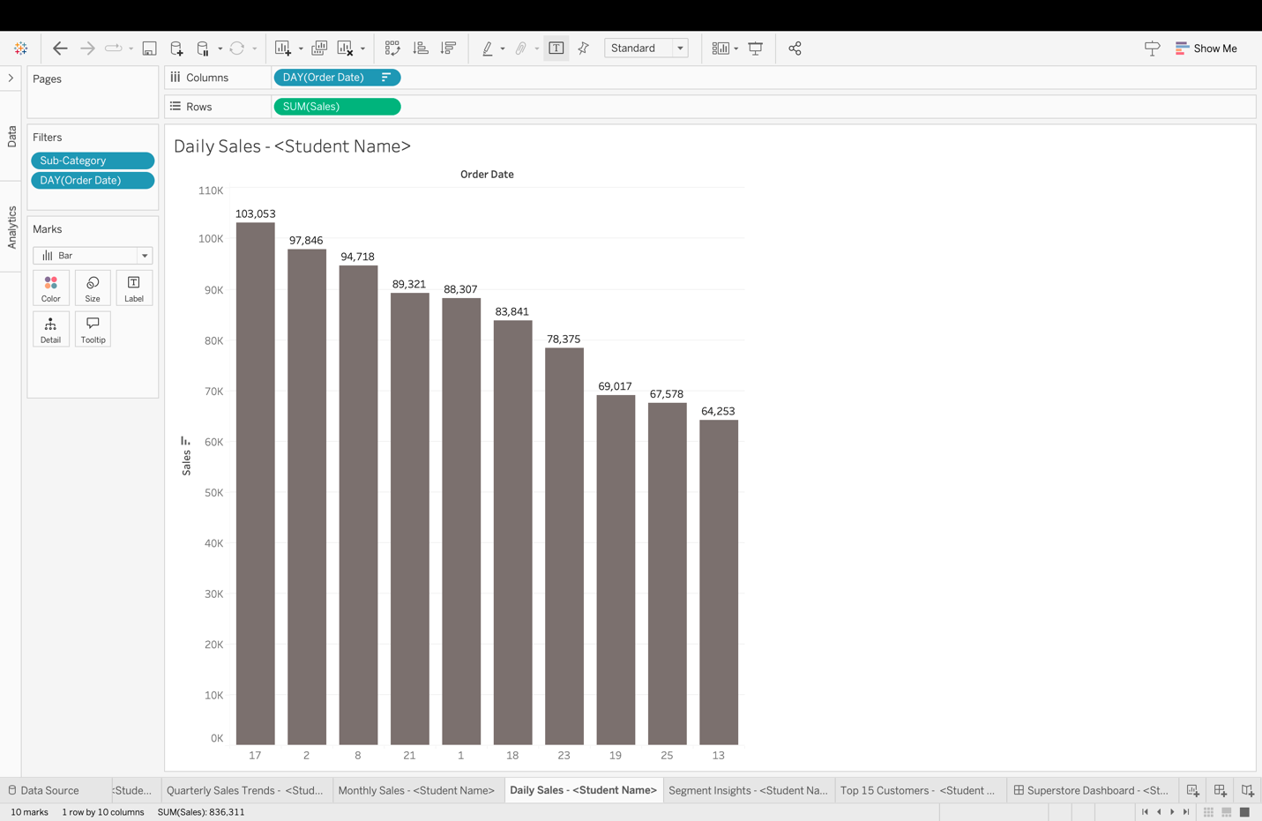

* The days with sales exceeding **$70,000** are the 1st, 2nd, 8th, 17th, 18th, 21st, and 23rd.

**Question 8: Paste the screenshot of the resulting screen.**

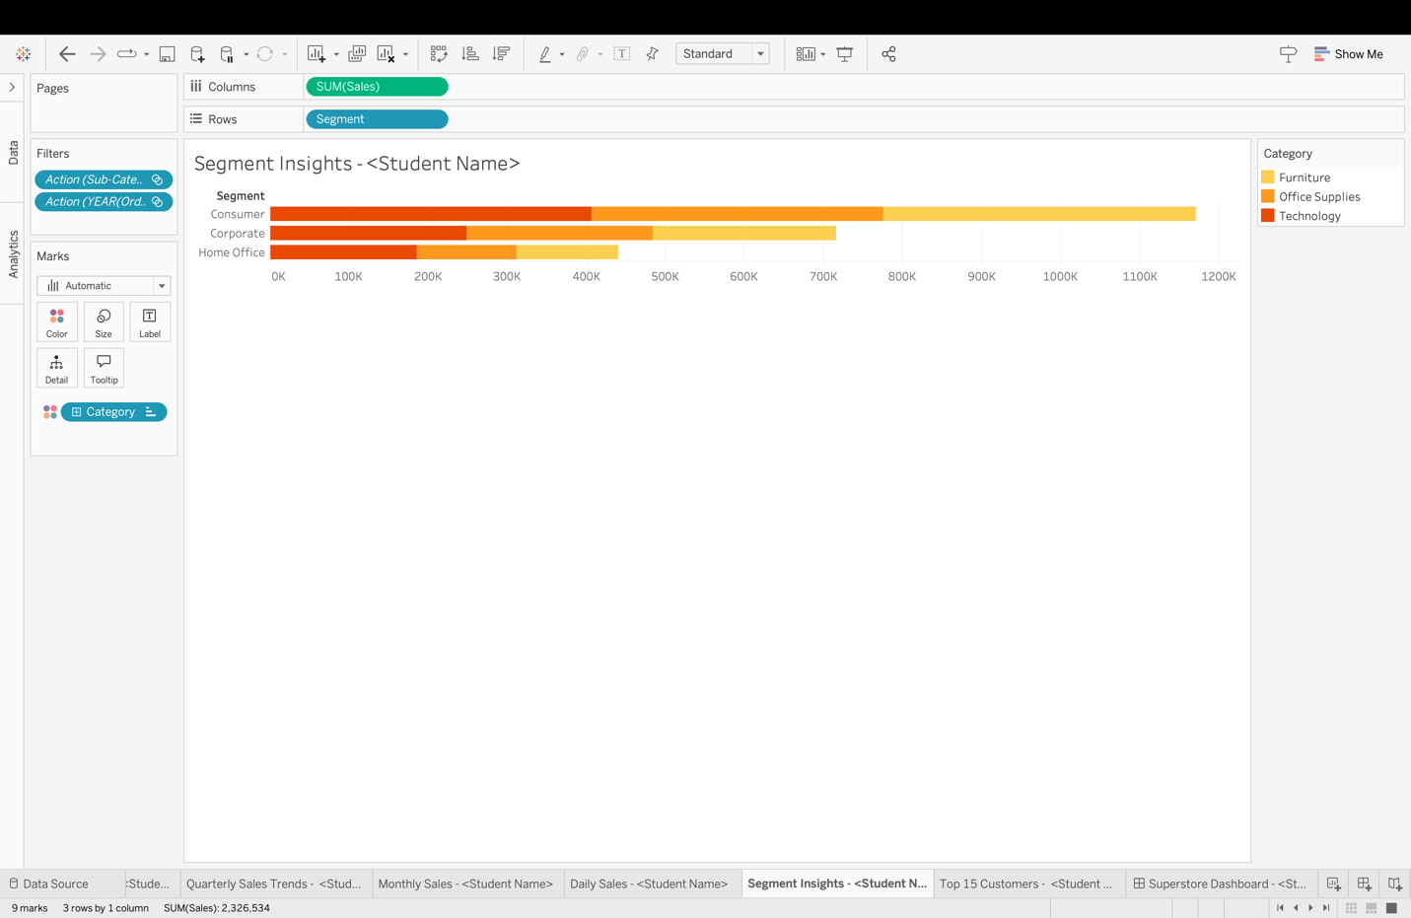

**Question 9 : Paste the screenshot of the resulting screen. Which customer has placed the most orders? How many?**

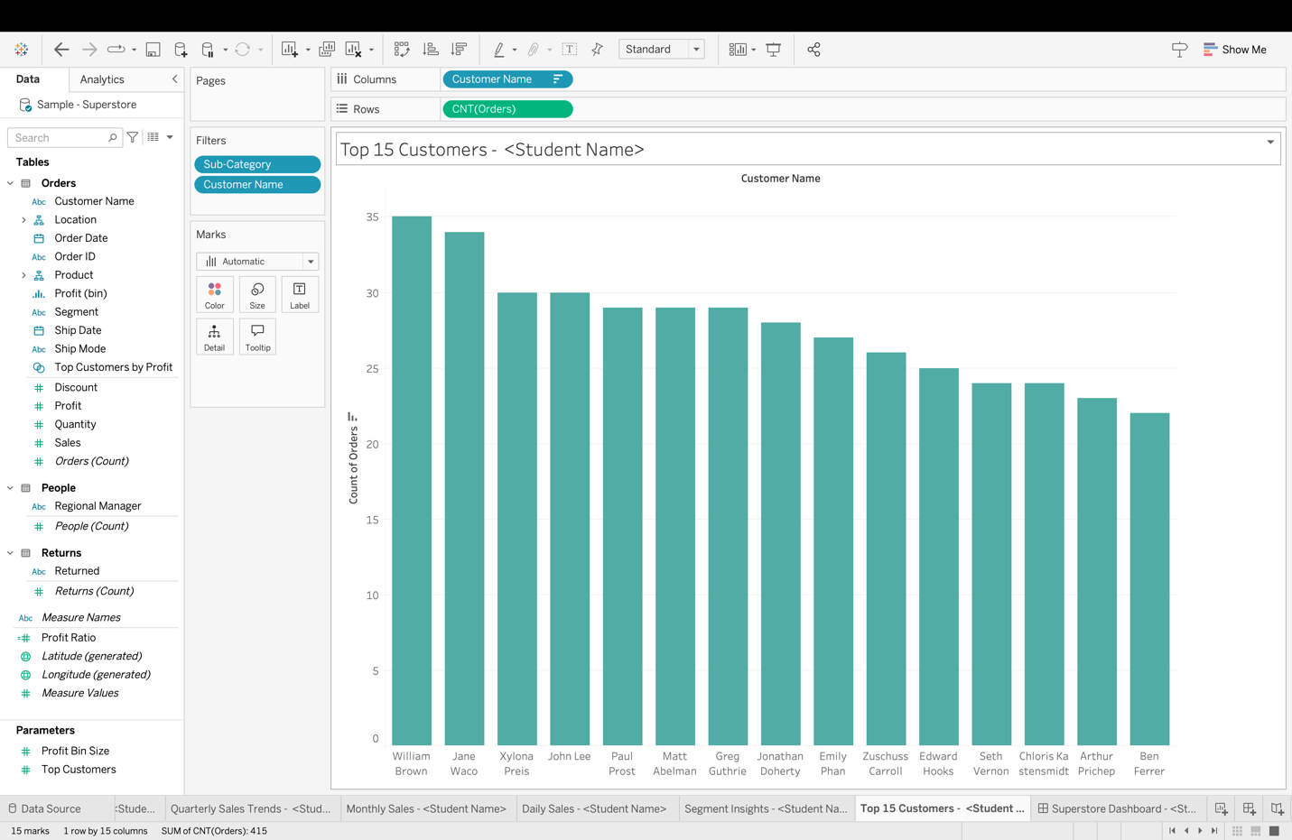

* Customer **William Brown** has placed the highest number of orders, totaling **35**.

**Question 10: Paste the screenshot of your Dashboard.**

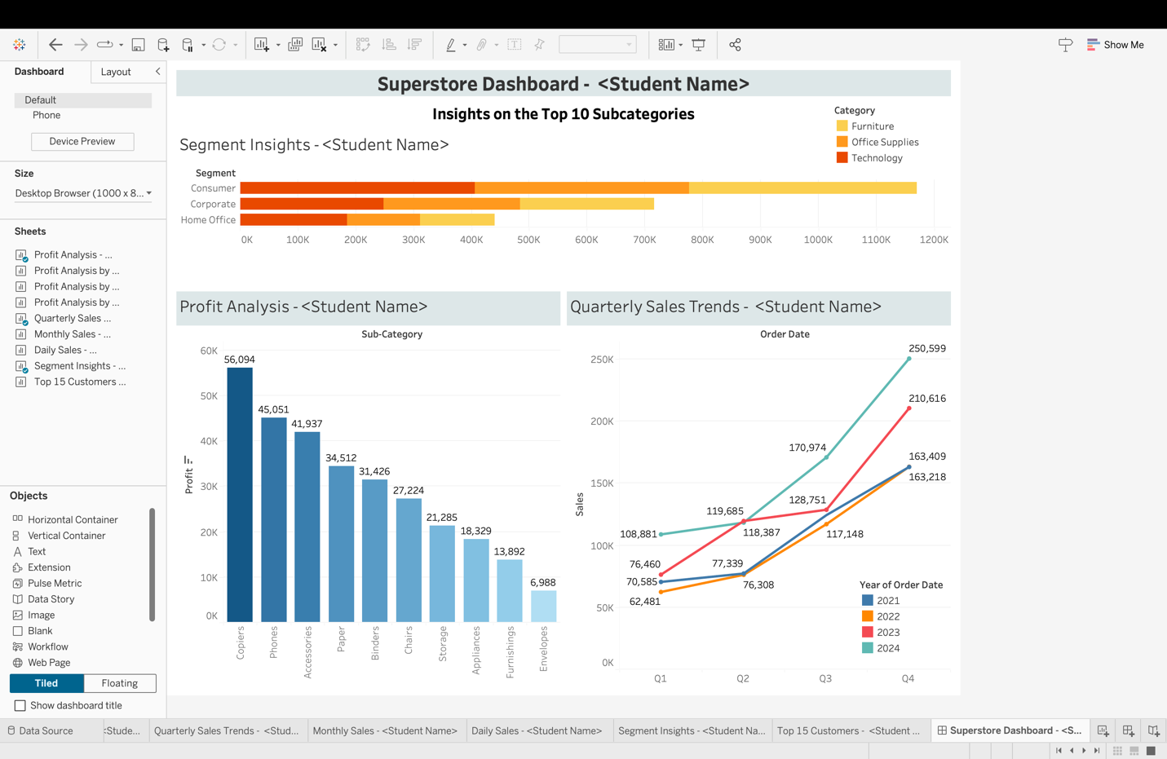

**Question 11: Paste the screenshot of the resulting screen of Tableau Cloud.**

Question 12: Paste the screenshot of the resulting screen.

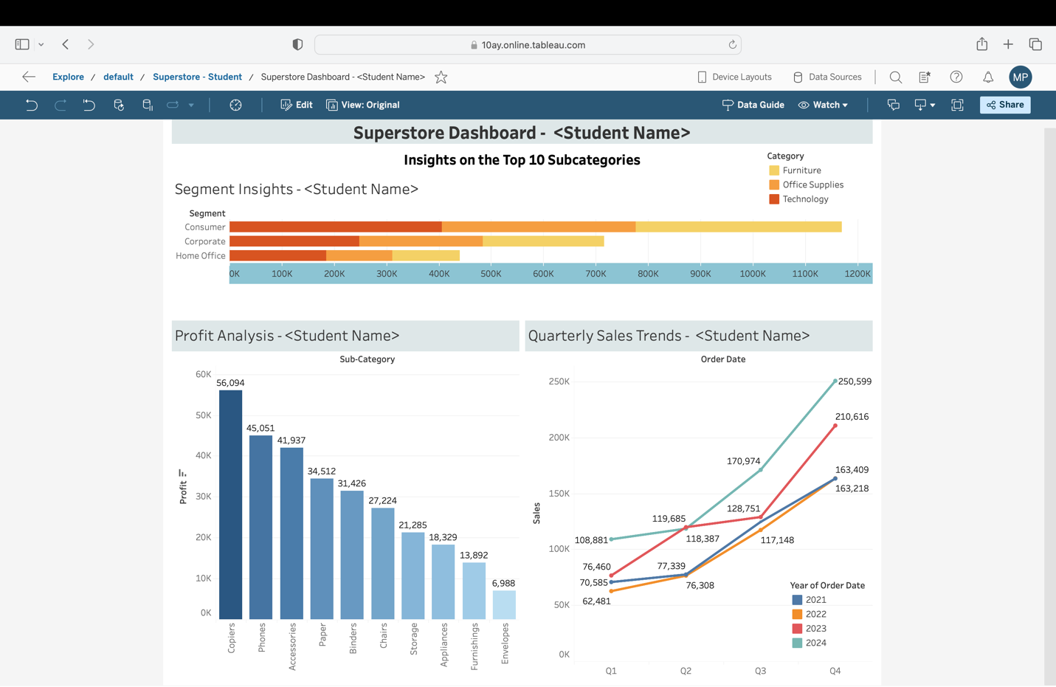

**Question 13: Hover your mouse over the Copiers section in the Profit Analysis dashboard. You will notice changes in the dashboard as you hover. Paste the screenshot of your screen when you hover over the Copiers.**

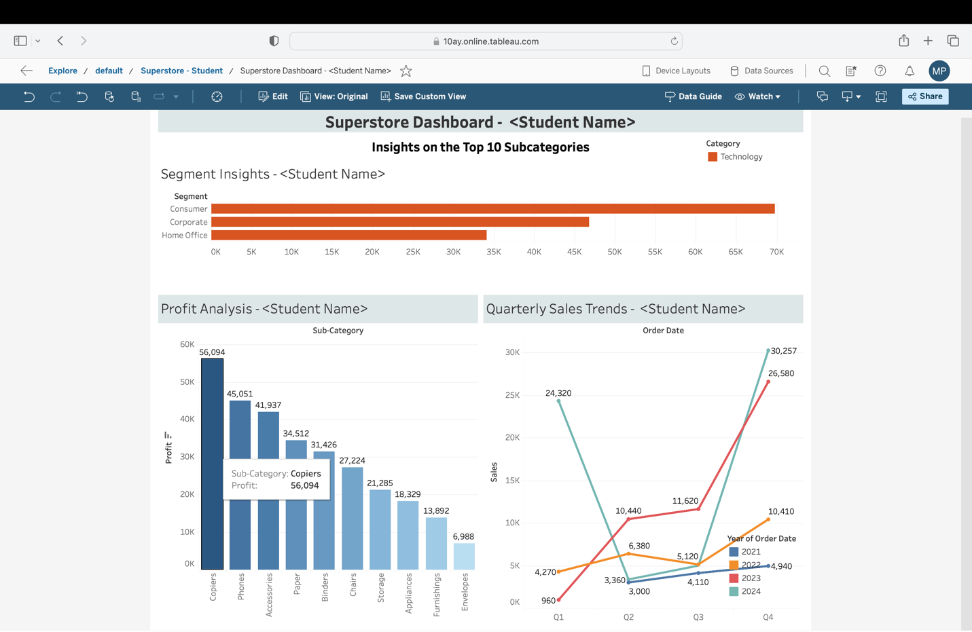

Question 14: Paste the screenshot of your Tableau Pulse.

Question15 : Paste the screenshot of the resulting screen.

Question 16: Paste the screenshot of the first three questions along with the answers provided by Ask Data.

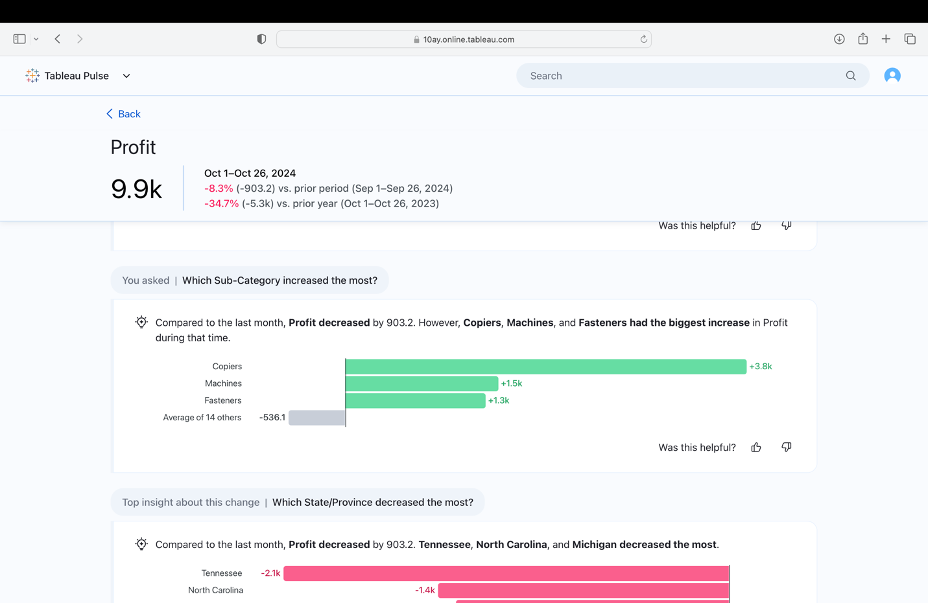

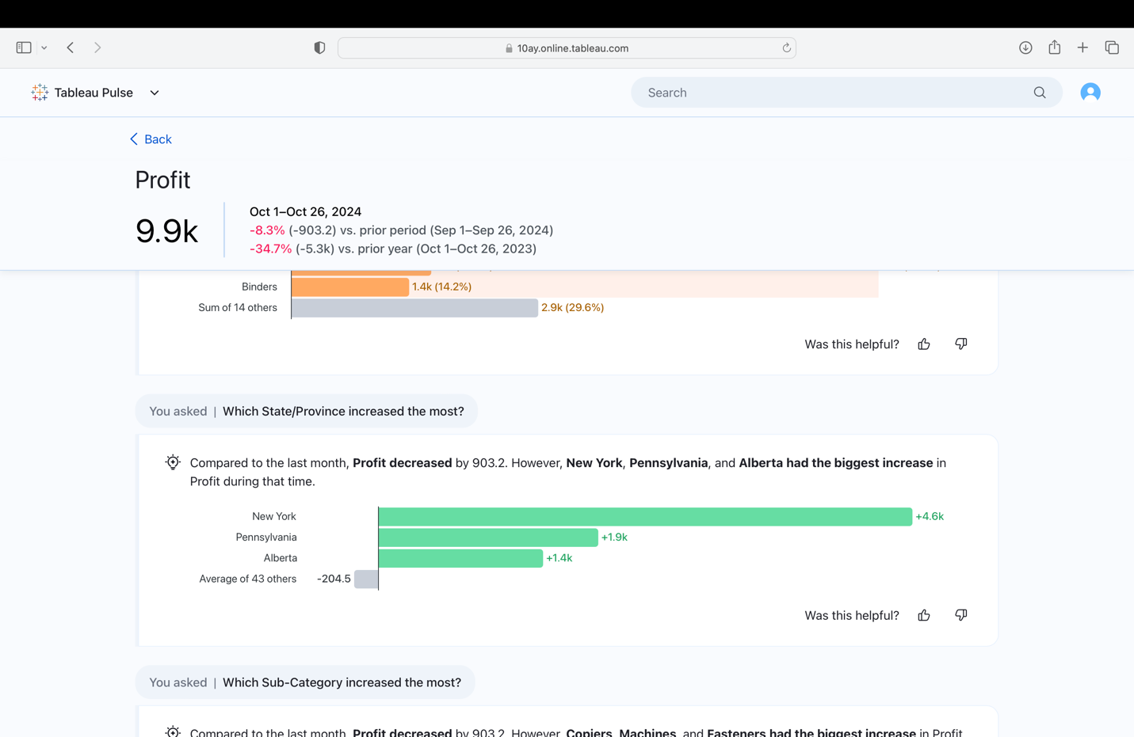

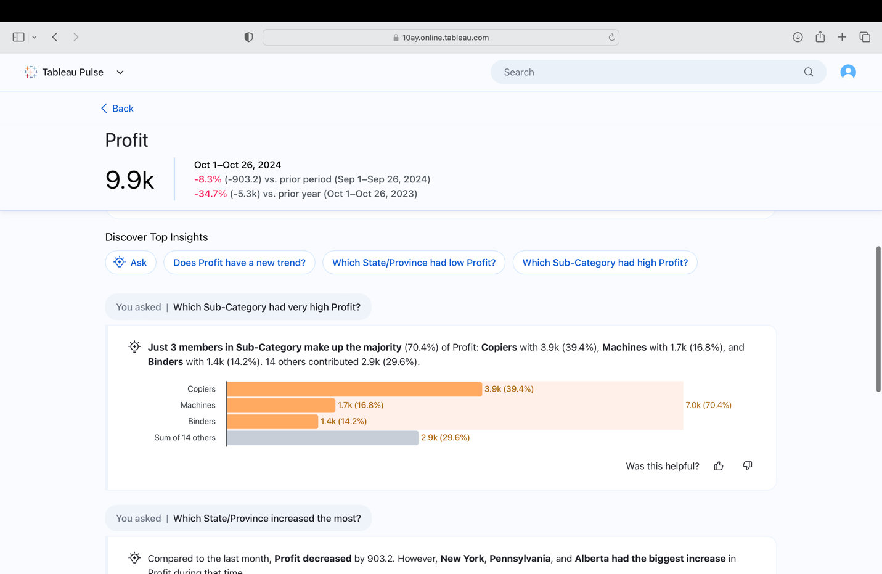

**Question 17: Paste the screenshot of the three questions you asked along with the corresponding visualizations.**

***(Each student’s questions will vary. We need to check for any repetition with questions already provided by AskData and review if the visualizations are appropriate.)***

Question 18: Paste the screenshot of the resulting screen.

Question 19: Paste the screenshot of the resulting screen.

**Question 20: Paste the screenshots of the first three questions Ask Data is suggesting, along with the answers provided.**

**Question 21: Write your own three questions in the Ask Data feature (different from the recommendations), and paste screenshots of those questions along with the answers generated by Ask Data**.

***(Each student’s questions will vary. We need to check for any repetition with questions already provided by AskData and review if the visualizations are appropriate.)***

**Question 22: Navigate back to the Tableau Pulse screen and Paste the screenshot of your matrices**

Question 23: Paste the screenshot of the resulting screen.

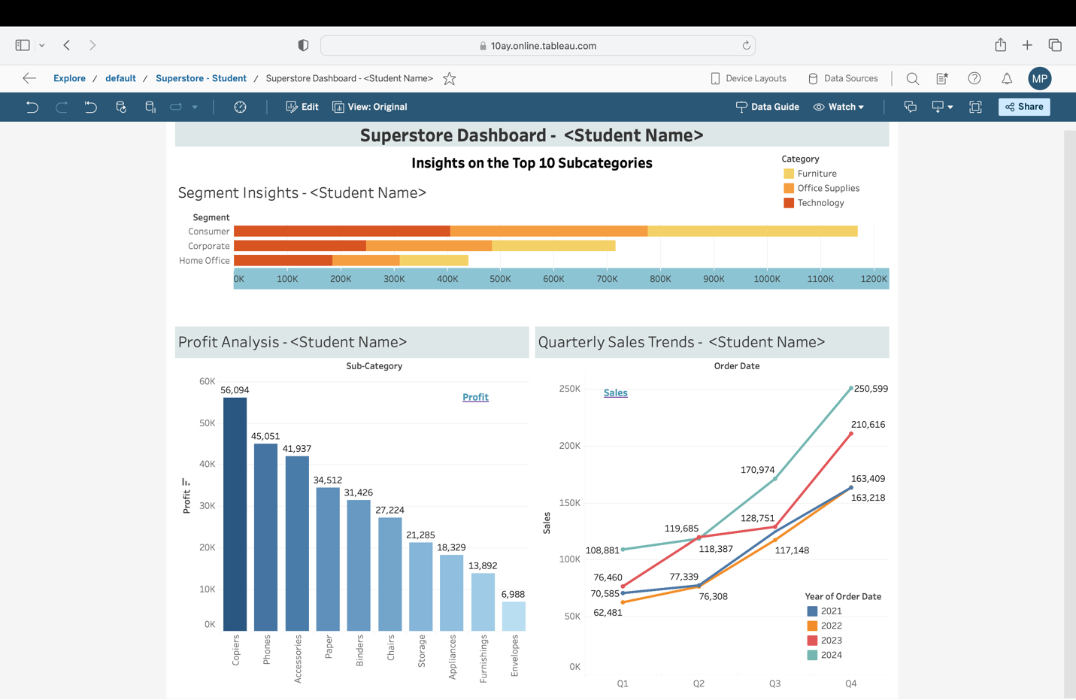

**Question 24: Click on each layout and paste a screenshot of each layout.**

